TO DESIGN AND SIMULATE A DIELECTRIC MODULATED AND DOUBLE AlGaN BARRIER PLASMA-BASED MOSHEMT FOR BIO-SENSING APPLICATIONS

Submitted By

Koushitha C-BU21EECE0100403,

Naga Chaitanya SV-BU21EECE0100521,

Martha Meghana-BU21EECE0100528

Under the Guidance of

Dr Girish Shankar Mishra

Associate Professor



Department of Electrical, Electronics and Communication Engineering GITAM School of Technology (DEEMED TO BE UNIVERSITY)

( Estd. u/s 3 of the UGC Act 1956)

NH 207, Nagadenehalli, Doddaballapur taluk, Bengaluru-561203 Karnataka, INDIA.

AY:2021-2025

DECLARATION

I/We declare that the project work contained in this report is original and it has been done by me under the guidance of my project guide.

|  |  |  |  |
| --- | --- | --- | --- |
| SL.No | Reg.No | Name of the student | Signature |
| 1 | BU21EECE0100403 | Koushitha C |  |
| 2 | BU21EECE0100521 | Naga Chaitanya s.v |  |
| 3 | BU21EECE0100528 | Martha Meghana |  |

Department of Electrical, Electronics and Communication Engineering [14 Bold]

GITAM School of Technology, Bengaluru-561203



CERTIFICATE

This is to certify that (Koushitha C, Naga Chaitanya SV, Martha Meghana) bearing (BU21EECE0100403,BU21EECE0100521,BU21EECE0100528)has satisfactorily completed the Major Project Entitled in partial fulfillment of the requirements as prescribed by the University for the VIIIth semester, Bachelor of Technology in

“Electrical, Electronics and Communication Engineering” submitted this report during the academic year 2024-2025.

[Signature of the Guide]

Dr. Girish Shankar Mishra

[Signature of HOD]

Dr Prithvi Sekhar Pagala

|  |  |  |
| --- | --- | --- |
| Chapter 1 | INTRODUCTION |  |
| 1.1 | Overview of the problem statement. |  |
| 1.2 | Objectives and goals |  |
| Chapter 2 | Literature Review |  |
| Chapter 3 | Strategic Analysis and Problem Definition |  |
| 3.1 | SWOT Analysis |  |
| 3.2 | Project Plan-GANTT Chart |  |
| 3.3 | Refinement of problem statement |  |
| Chapter 4 | Methodology |  |
| 4.1 | Description of the approach |  |
| 4.2 | Tools and techniques utilized |  |
| 4.3 | Design Considerations |  |
| 4.4 | Applications |  |
| Chapter 5 | Implementation |  |
| 5.1 | Description pf how the project was executed |  |
| 5.2 | Challenges faced and solutions implemented |  |
| Chapter 6 | Results |  |
| 6.1 | Outcomes |  |
| 6.2 | Interpretation of result |  |
| 6.3 | Comparison with existing literature of technologies |  |
| Chapter 7 | Conclusion |  |
| Chapter 8 | Future work |  |
|  | References |  |
|  |  |  |

|  |
| --- |
| CONTENTS  NAME Page No |

**ABSTRACT**

This project focuses on designing and simulating a dielectric-modulated, double-AlGaN barrier charge plasma-based MOSHEMT for biosensing applications. The device incorporates dielectric cavities within the gate region, where biomolecules alter the dielectric constant, leading to significant variations in electrical characteristics. This enhances sensitivity and selectivity, allowing for precise biomolecule detection. The dual-channel architecture improves current conduction by providing a larger interaction surface, while the charge plasma technique eliminates the need for doping, simplifying fabrication and ensuring reliability.

Extensive TCAD simulations validate the device’s superior performance by analyzing critical parameters such as Id-Vd and Id-Vg characteristics. The results demonstrate notable improvements in biosensing capabilities, confirming its effectiveness in detecting biomolecules like proteins, nucleic acids, and small molecules. With high sensitivity, low power consumption, and scalability, the proposed MOSHEMT biosensor is ideal for integration into portable and wearable diagnostic devices, making it a significant advancement in biomedical applications.

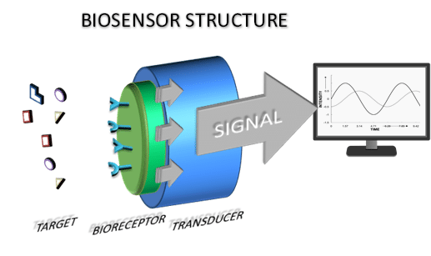

Fig 1. Bio Sensor Structure

**Chapter 1**

**Introduction**

The rapid advancement of biosensing technology has led to the development of highly sensitive and efficient devices for detecting biomolecules, gases, and chemical analytes. Among these, Metal Oxide Semiconductor High Electron Mobility Transistors (MOSHEMTs) have gained significant attention due to their high electron mobility, low power consumption, and superior signal processing capabilities. This report focuses on the design and simulation of a dielectric-modulated, double AlGaN barrier, plasma-based MOSHEMT for biosensing applications.

The incorporation of a dielectric modulation mechanism enhances the sensitivity of the MOSHEMT by altering the charge distribution in response to the presence of biomolecules. Additionally, the double AlGaN barrier structure improves carrier confinement, leading to higher electron mobility and better device performance. The use of a plasma-based approach further optimizes the transistor’s characteristics, making it ideal for real-time, label-free biosensing.

This study aims to analyze the electrical and sensing performance of the proposed MOSHEMT structure using simulation techniques. The results will provide insights into its potential for highly sensitive, rapid, and reliable biosensing applications, addressing the growing need for advanced biomedical and environmental monitoring systems.

**1.1 Overview of the problem statement**  
 Biosensors play a crucial role in modern diagnostics, offering rapid and sensitive detection of biomolecules for applications ranging from medical diagnostics to environmental monitoring. However, enhancing their sensitivity and selectivity remains a significant challenge. This project aims to design and simulate a dielectric-modulated, double AlGaN barrier plasma-based Metal Oxide Semiconductor High Electron Mobility Transistor (MOSHEMT) specifically for biosensing applications. The unique combination of dielectric modulation and charge plasma techniques in this design aims to address existing limitations in sensitivity and scalability, making the device suitable for detecting biomolecules like proteins and nucleic acids. The project explores how dielectric modulation affects the sensitivity of the MOSHEMT, optimizing the device structure for improved performance in a range of conditions.

**1.2 Objectives and goals:**

The objectives of this project are:

* Investigate the impact of dielectric modulation on the performance of a double AlGaN barrier charge plasma-based MOSHEMT.
* Enhance the sensitivity of the device for biosensing applications by optimizing dielectric constant variations.
* Improve drain current (IDSI_{DS}IDS​) and overall device efficiency through structural modifications.
* Analyze the effect of the double AlGaN barrier in enhancing carrier confinement and mobility.
* Evaluate the influence of different biomolecules on device sensitivity and electrical characteristics.
* Perform comparative simulations of MOSHEMT structures with varying dielectric properties.
* Optimize the gate engineering and cavity design to achieve high-performance biosensing.
* Study the reliability and feasibility of the proposed MOSHEMT for real-time biosensing applications.

Main Goals:

* Develop a high-sensitivity biosensor using a dielectric-modulated double AlGaN barrier MOSHEMT.
* Enhance carrier transport and device performance through optimized structural design.
* Achieve significant drain current improvement for better detection capability.
* Ensure efficient charge plasma formation for enhanced biosensing applications.
* Validate the proposed device through extensive simulations and comparative analysis.

Chapter 2

**Literature Review**

We have discussed several projects related to double AlGaN. Each of these projects comes

with its unique set of challenges and considerations. Here is a brief overview and some comments

on each of them  
**1. Analytical Modeling and Simulation of AlGaN/GaN MOS-HEMT for High Sensitivity pH Sensor**

* **Device Simulation:**  
  This study involves the virtual fabrication of an AlGaN/GaN MOS-HEMT structure integrated with an electrolyte-filled cavity. This setup is essential for detecting changes in pH levels accurately.
* **Analytical Model Development:**  
  The research focuses on modeling the drain current and threshold voltage variations with different pH levels. This allows for understanding the sensor's response to pH changes.
* **Validation:**  
  The model's predictions are compared with experimental and simulated data to ensure accuracy and enhance the understanding of sensitivity.
* **Key Findings:**
  + High sensitivity and quick response times are achieved.
  + Improved device performance across a wide range of applications is noted.
  + Challenges include limited analytical modeling and complexities in fabrication that may hinder practical implementation.

**2. Linear and Circular AlGaN/AlN/GaN MOS-HEMT-Based pH Sensor on Si Substrate: A Comparative Analysis**

* **Methodology:**  
  This research virtually fabricates an AlGaN/GaN MOS-HEMT sensor, including a cavity for electrolyte solutions, to facilitate pH sensing.
* **Analytical Model Development:**  
  An analytical model is created to predict the changes in drain current and threshold voltage based on varying pH levels.
* **Validation:**  
  The accuracy of the model is confirmed through comparison with experimental and simulated data.
* **Key Findings:**
  + The sensor demonstrates high sensitivity and quick response times.
  + Challenges include limited analytical modeling and the need for further exploration beyond the Nernstian limit, along with complexities in fabrication.

## **3. High-Sensitivity pH Sensor Based on Coplanar Gate AlGaN/GaN Metal-Oxide-Semiconductor High Electron Mobility Transistor**

* **Device Fabrication:**  
  The study involves growing AlGaN/GaN heterostructures on sapphire substrates, followed by the deposition of GaN, AlGaN, and SiO₂/Ta₂O₅ layers.
* **Resistive Coupling:**  
  Utilizing resistive coupling between the control gate (CG) and sensing gate (SG) enhances sensitivity, providing better performance in pH detection.
* **Extended Gate Sensing:**  
  An extended gate sensing unit is introduced to prevent direct exposure of the HEMT to pH solutions, reducing potential damage.
* **Key Findings:**
  + The sensor achieves high sensitivity beyond the Nernst limit, showcasing a cost-effective and damage-resistant design.
  + The study highlights limited exploration of hysteresis and drift and emphasizes the need for scalability in commercial applications.

**4. A Dielectric-Modulated Normally-Off AlGaN/GaN MOSHEMT for Bio-Sensing Applications: Analytical Modeling Study and Sensitivity Analysis**

* **Device Fabrication:**  
  The AlGaN/GaN MOSHEMT device is fabricated using metal-organic chemical vapor deposition (MOCVD) on a silicon substrate.
* **Simulation:**  
  A 2D drift-diffusion model simulates carrier transport, considering dielectric constants, energy bands, and surface potential of biomolecules.
* **Analytical Modeling:**  
  The study develops an analytical model focusing on the threshold voltage shift (ΔVth) caused by biomolecule interactions. Validation is conducted against TCAD simulation results.
* **Key Findings:**
  + The device demonstrates high sensitivity and label-free detection capabilities.
  + It is compatible with CMOS technology and operates effectively in harsh environments.
  + The study identifies a lack of analytical studies on MOSHEMTs and emphasizes the need for experimental validation and parameter optimization.

**5. Fabrication and Charge Deduction Based Sensitivity Analysis of GaN MOS-HEMT Device for Glucose, MIG, C-erbB-2, KIM-1, and PSA Detection**

* **Device Fabrication:**  
  An AlGaN/AlN/GaN MOS-HEMT device is fabricated using MOCVD on a silicon substrate, followed by the deposition of source/drain and gate contacts.
* **Charge Deduction Model:**  
  A charge deduction-based approach is developed to estimate device sensitivity for various biomarkers by applying equivalent interface charge as gate bias.
* **Sensitivity Analysis:**  
  Sensitivity is evaluated using metrics like drain current, channel potential, and channel conductance for different biomarkers.
* **Key Findings:**
  + The study highlights the importance of real-time validation and assumptions in charge distribution.
  + Emphasizes the need for optimization of sensing metrics to improve the overall device performance.

# Chapter 3

# Strategic Analysis and Problem Definition

# **Strategic Analysis:** The demand for highly sensitive and selective biosensors in biomedical applications is increasing. Conventional AlGaN/GaN-based biosensors face challenges like limited sensitivity, complex fabrication, and high power consumption. The proposed MOSHEMT overcomes these issues using dielectric modulation, a dual-channel structure, and charge plasma techniques for enhanced performance.

# **Problem Definition:** Traditional biosensors suffer from inconsistent detection due to limited surface interaction and inefficient charge modulation. This project aims to improve biosensing efficiency by optimizing current conduction and eliminating doping, making the MOSHEMT highly sensitive, low-power, and suitable for real-time, portable diagnostics.

## SWOT Analysis:

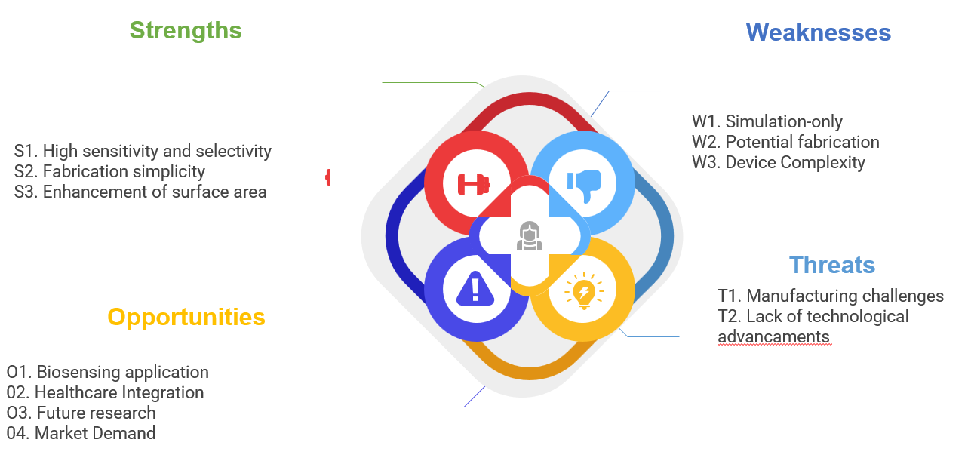

3.2 Project Plan - GANTT Chart :

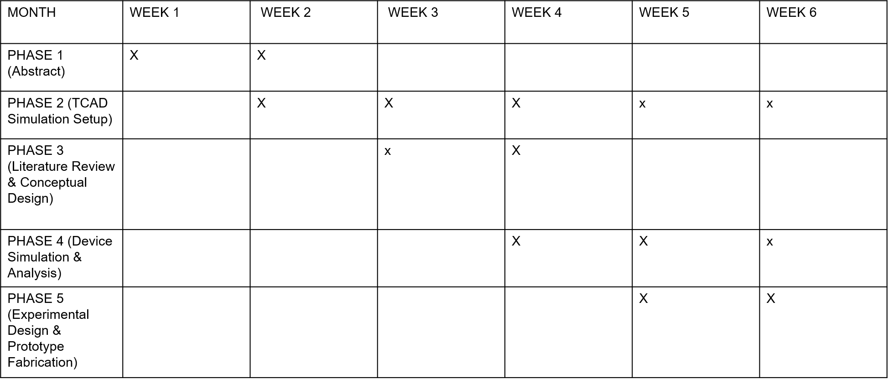

10

#### 

##### 

##### **\**

##### **3.3 Refinement of problem statement:**

##### Conventional biosensors face challenges such as limited sensitivity, high power consumption, and fabrication complexity, which hinder their efficiency in real-time biomedical applications. To address these limitations, this project focuses on designing a dielectric-modulated, double-AlGaN barrier charge plasma-based MOSHEMT. By integrating dielectric cavities, a dual-channel structure, and charge plasma techniques, the device enhances biomolecule detection, improves current conduction, and eliminates doping requirements. This refined approach ensures high sensitivity, low power consumption, and scalability, making it ideal for portable and wearable biosensing applications.

**3.4 Continuation of analyzing the problem statement**

##### The limitations of conventional biosensors, such as low detection accuracy, high fabrication complexity, and increased power consumption, highlight the need for innovative solutions. The proposed dielectric-modulated, double-AlGaN barrier charge plasma-based MOSHEMT addresses these challenges by leveraging dielectric modulation to enhance sensitivity and selectivity.

##### By incorporating a dual-channel structure, the device increases charge carrier mobility and improves current conduction, ensuring efficient biomolecule detection. The charge plasma technique further eliminates doping requirements, simplifying fabrication while maintaining device reliability.

**Chapter 4**

**Methodology**

# 4.1 **Description of the approach:**

# The proposed approach involves designing and simulating a dielectric-modulated, double-AlGaN barrier charge plasma-based MOSHEMT to enhance biosensing capabilities. The device incorporates dielectric cavities within the gate region, where target biomolecules influence the dielectric constant, altering the electrical characteristics and improving sensitivity. Extensive TCAD simulations are conducted to analyze Id-Vd, Id-Vg characteristics, and sensitivity graphs, validating the device’s effectiveness in detecting biomolecules. This approach ensures high sensitivity, low power consumption, and scalability for portable and wearable biosensing applications.

# Phase 2:

# **Simulate the MOSHEMT device** using TCAD tools for performance analysis.

# **Evaluate electrical characteristics** such as Id-Vd and Id-Vg curves under biomolecule interactions.

# **Analyze key performance parameters** including sensitivity, current conduction, charge carrier mobility, and power consumption.

# **Compare device performance** with and without dielectric modulation and the dual-channel configuration.

# **Study the impact of dielectric variations** on charge transport and overall device efficiency.

# **Assess threshold voltage shifts and transconductance variations** due to biomolecule presence.

# **Investigate high-frequency and high-power performance** to determine suitability for biosensing applications.

# **Optimize the device structure** based on simulation results for enhanced detection accuracy.

# **Validate the MOSHEMT’s effectiveness** for real-world biosensing applications and potential integration into diagnostic devices

# **Design of Dielectric Modulated MOSHEMT**

# The design of dielectric modulated MOSHEMT (Metal-Oxide-Semiconductor High Electron Mobility Transistor) integrates a dielectric cavity within the gate region to enhance sensitivity for biosensing applications. The device features a double AlGaN barrier structure to improve charge plasma formation, leading to enhanced carrier mobility and increased drain current. The memory effect in the charge plasma region facilitates precise detection of biomolecules through dielectric constant variations. A controlled gate voltage modulates the charge carrier concentration, ensuring stable and high-performance operation. This design enables selective detection of biomolecules, making it suitable for biosensors in healthcare diagnostics and environmental monitoring.

# **2. Simulation of Dielectric Modulated Double AlGaN Barrier MOSHEMT**

# The simulation of the proposed MOSHEMT involves analyzing its electrical characteristics under different dielectric constants to evaluate its biosensing capabilities. The device structure is modeled using a 2D TCAD (Technology Computer-Aided Design) framework, incorporating parameters such as gate length, dielectric cavity dimensions, and oxide thickness. The drain current (I_DS) and transconductance (g_m) are analyzed against variations in the dielectric constant of the sensing region, demonstrating how biomolecules influence device performance. By optimizing the gate bias and cavity dimensions, the MOSHEMT achieves high sensitivity, selectivity, and low power consumption, making it a promising candidate for next-generation bio-sensing applications.

### **4.2 Tools and Techniques Utilized**

### In designing and simulating the dielectric modulated and double AlGaN barrier plasma-based MOSHEMT for biosensing applications, **TCAD (Technology Computer-Aided Design)** was the primary tool used for device modeling and performance analysis.

### **Tool Used:** **TCAD**

### **Purpose:** To simulate and analyze the electrical characteristics of the MOSHEMT structure under different dielectric modulations.

### **Key Features and Utilization:**

### **Device Simulation:**

### Implemented **2D/3D device modeling** to study the impact of the double AlGaN barrier on charge plasma formation.

### Simulated **I_DS–V_DS** and **I_DS–V_GS** characteristics to observe drain current variations.

### **Dielectric Modulation Analysis:**

### Modeled the effect of biomolecules with different dielectric constants in the cavity region.

### Evaluated how the dielectric modulation influences the charge carrier transport and device sensitivity.

### **Process Simulation:**

### Defined material properties, doping concentrations, and interface effects for accurate MOSHEMT behavior prediction.

### Analyzed the gate control mechanism and subthreshold performance.

### **Performance Optimization:**

### Conducted parametric analysis to optimize device geometry and improve biosensing efficiency.

### Evaluated threshold voltage shifts and sensitivity metrics for different biomolecules.

#### **4.3 Design considerations:**

The design of the dielectric modulated and double AlGaN barrier plasma-based MOSHEMT involves several critical considerations to optimize its performance for biosensing applications. These include material selection, surface area optimization, dielectric modulation effects, integration feasibility, and scalability. Each of these aspects plays a vital role in ensuring high sensitivity, stability, and practical implementation of the device.

**4.3.1 Material Selection**

The choice of semiconductor materials is crucial in determining the carrier mobility, device efficiency, and overall sensitivity of the MOSHEMT. AlGaN/GaN heterostructures are selected due to their superior high-electron-mobility properties, allowing the formation of a Two-Dimensional Electron Gas (2DEG) at the heterointerface. This enhances carrier transport, reducing power dissipation while improving current conduction. The presence of a double AlGaN barrier further refines charge plasma formation, ensuring better electrostatic control and reducing leakage currents. Proper doping and interface engineering also help minimize surface traps and defects, which can impact the biosensor's accuracy.

**4.3.2 Surface Area Optimization**

Enhancing the surface area is a fundamental design strategy to improve the interaction between the MOSHEMT and target biomolecules. By modifying the gate structure and optimizing the cavity dimensions, a larger active sensing region is created, allowing more biomolecules to attach, leading to higher sensitivity. Nanostructured modifications or functionalized dielectric coatings can be incorporated to improve molecular adhesion, facilitating better charge modulation. The increased surface-to-volume ratio ensures that even low-concentration biomolecule detection results in a noticeable electrical response, crucial for high-precision medical diagnostics.

**4.3.3 Dielectric Modulation Effects**

The dielectric constant of biomolecules plays a significant role in modulating the electric field distribution within the MOSHEMT. The introduction of biomolecules into the cavity region alters the capacitance, leading to threshold voltage shifts and variations in drain current (I_DS). By carefully selecting high-k dielectric materials and engineering the cavity placement, the device response can be fine-tuned for maximum sensitivity. Additionally, reducing background noise and ensuring a high signal-to-noise ratio (SNR) are critical for reliable biosensing. Advanced TCAD simulations help analyze and optimize these effects, ensuring the MOSHEMT achieves precise biomolecule detection.

**4.3.4 Integration Feasibility**

For practical applications, the MOSHEMT design must be compatible with existing semiconductor fabrication techniques and biosensing platforms. The use of standard CMOS-compatible processing enables easy integration into lab-on-chip systems and portable medical devices. Additionally, the sensor must be able to operate efficiently at low power while maintaining stable electrical characteristics in real-world conditions. Ensuring biocompatibility through appropriate passivation layers and surface functionalization techniques allows the sensor to function effectively in biological environments, making it suitable for real-time, on-field diagnostics.

**4.3.5 Scalability**

Scalability is essential to ensure that the proposed MOSHEMT biosensor can be fabricated cost-effectively for large-scale applications. The device structure and fabrication steps should be optimized to allow mass production while maintaining performance consistency. Techniques such as photolithography and atomic layer deposition (ALD) can be leveraged to ensure uniformity in sensor performance. Additionally, by designing the MOSHEMT with adjustable cavity dimensions, it can be adapted for detecting different biomolecules, expanding its application across various medical and environmental sensing domains.



**4.4 Application Implemented on Biosensor:**

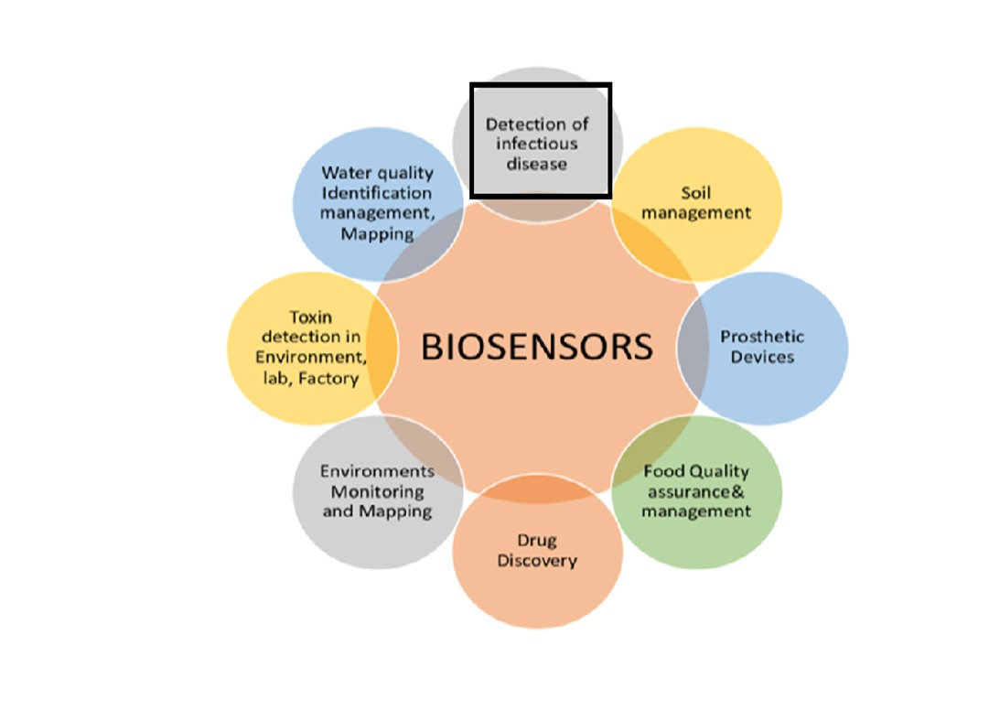

**4.4.1 Biomedical Diagnostics**

The proposed MOSHEMT biosensor is highly effective in biomedical diagnostics, enabling the detection of biomolecules such as proteins, nucleic acids, and small molecules. By leveraging dielectric modulation, the device provides high

sensitivity and selectivity, making it suitable for disease detection and monitoring.

**4.4.2 Detection of Infectious Diseases**

The biosensor can be effectively used for detecting infectious diseases such as COVID-19, tuberculosis, and HIV by identifying specific viral or bacterial biomarkers. The dielectric-modulated structure enhances detection sensitivity, allowing real-time monitoring of infections at very low concentrations.

**4.4.3 Food Quality Assurance & Management:**  
It enhances food safety by detecting harmful bacteria, allergens, and chemical contaminants in food products. The sensor ensures quality control in food processing, preventing contamination and ensuring consumer safety.

**4.4.4 Environmental Monitoring & Mapping:**  
The device is used to detect pollutants, toxins, and hazardous chemicals in air, soil, and water. By integrating with IoT systems, it provides real-time mapping of contamination levels, aiding in environmental conservation efforts.

**4.4.5 Water Quality Identification & Management:**  
This biosensor helps detect contaminants, heavy metals, and pathogens in water sources by analyzing biochemical interactions. Its high sensitivity allows for efficient water quality monitoring, ensuring safe drinking water and environmental protection.

## 

# **Chapter 5**

# **Implementation:**

Implementation of the work included design and simulation using TCAD software for dielectric-modulated, double AlGaN barrier MOSHEMT project. The development included a thorough analysis and model of the device, seeking to maximize electron mobility in AlGaN/GaN layers. By performing a series of simulations, key electrical characteristics such as drain current and threshold voltage are analysed at different conditions to investigate the device susceptibility towards biomolecule interactions. Using simulation outputs, designers iteratively refined the design to find best values for parameters such as dielectric properties and layer thicknesses. These simulation outputs then validate against theoretical models to provide an established comprehensive solution, and a way was incepted for fabrication where it generated which materials would be used, what will be technique(s) that are half-finished-Version of future iterations. While the challenges such as modeling complexity and handling large data set(s) remained, a systematic approach to defining variables allowed empirical progress and laid down the groundwork for future experimental testing of MOSHEMT biosensor fabrication**.**

**5.1 Description of the Project**

**5.1.1 Project Planning and Requirements for MOSHEMT-Based Biosensor**

Effective planning is crucial for the successful development of the dielectric modulated and double AlGaN barrier plasma-based MOSHEMT for biosensing applications. The initial phase involves defining key design parameters such as channel dimensions, dielectric cavity structure, gate oxide properties, and source-drain configurations. Since the MOSHEMT operates based on dielectric modulation effects, precise optimization of dielectric material selection, threshold voltage sensitivity, and carrier mobility is essential. The project must also address biosensing sensitivity, fabrication feasibility, and stability to ensure real-world applicability. Establishing a clear roadmap, identifying necessary TCAD simulation tools, and defining performance benchmarks help streamline the development process and enhance device efficiency.

**5.1.2 Design Approach Selection**

The design of the MOSHEMT biosensor is centered on enhancing charge plasma formation and carrier transport properties through a double AlGaN barrier structure. Unlike conventional FET-based biosensors, this architecture improves electrostatic control while minimizing leakage currents. The cavity-based dielectric modulation technique ensures that the presence of biomolecules induces detectable electrical variations, enabling highly sensitive detection. The gate engineering and AlGaN barrier thickness optimization play a crucial role in tuning the threshold voltage shifts caused by dielectric perturbations. This design approach ensures an optimal balance between high sensitivity, low power consumption, and fabrication feasibility.

**5.1.3 TCAD-Based Design and Simulation**

The MOSHEMT design is implemented using Technology Computer-Aided Design (TCAD) simulations, enabling precise modeling of electrical, structural, and material properties. The core components of the simulation include device geometry definition, doping concentration optimization, and quantum transport analysis. The Poisson equation and drift-diffusion model are used to study carrier behavior under different biasing and biomolecule attachment conditions. By incorporating 2D and 3D physics-based modeling, the MOSHEMT is evaluated for threshold voltage shifts, current-voltage characteristics (I_DS-V_GS), and sensitivity performance. Well-documented simulation data ensures iterative optimization for real-world biosensing applications.

**5.1.4 Functional Simulation and Performance Evaluation**

Once the MOSHEMT structure is optimized, extensive TCAD-based simulations are conducted to validate its biosensing capabilities. The device undergoes testing under various biomolecule attachment scenarios, where different dielectric constants influence the electrical response. Performance metrics such as subthreshold slope, ON/OFF current ratio, charge density variations, and gate capacitance shifts are analyzed to assess sensor reliability. Additionally, sensitivity analysis is performed by simulating various biomolecule concentrations to determine the limit of detection (LoD). The final evaluation ensures the MOSHEMT exhibits stable operation, high detection accuracy, and compatibility with bio-integrated platforms.

**5.2 Challenges faced and solutions implemented:**

**Challenge: Modeling Complex Interactions:**Simulating the interactions between the MOSHEMT’s dielectric layer and biomolecules presented challenges due to the complexity of the dielectric modulation.

* **Solution:**  
  The team used a modular approach, analyzing one parameter at a time before integrating them into a complete model, which allowed for a more manageable understanding of the effects on the overall device.

**Challenge: Achieving Optimal Sensitivity and Selectivity:**Balancing sensitivity and selectivity required precise adjustments to the dielectric properties and the double AlGaN barriers.

* **Solution:**  
  Multiple iterations of the simulation were conducted with fine-tuned adjustments to optimize these properties, leading to improved performance metrics.

**Challenge: Simulation Limitations for Real-World Scenarios:**Simulations may not fully capture all real-world conditions, which posed a risk in terms of predicting the device's actual performance.

* **Solution:**  
  A plan for future experimental validation was created to test the device under practical conditions, ensuring that simulation results could be translated effectively into real-world performance.

**Challenge: Data Management:**The large volume of data generated during the simulations required efficient management for analysis and reporting.

* **Solution:**  
  Automation scripts and data analysis tools were employed to streamline the data extraction and processing, improving the efficiency and accuracy of analysis.

# **Chapter 6**

# **Results:**

The simulation results of the dielectric-modulated, double AlGaN barrier MOSHEMT reveal several insights into its performance as a biosensor, highlighting its potential advantages and areas of strength

**STAGE 1: STAGE 2:**

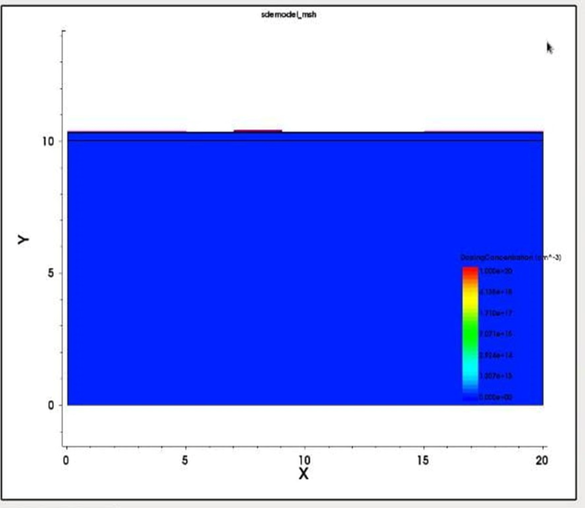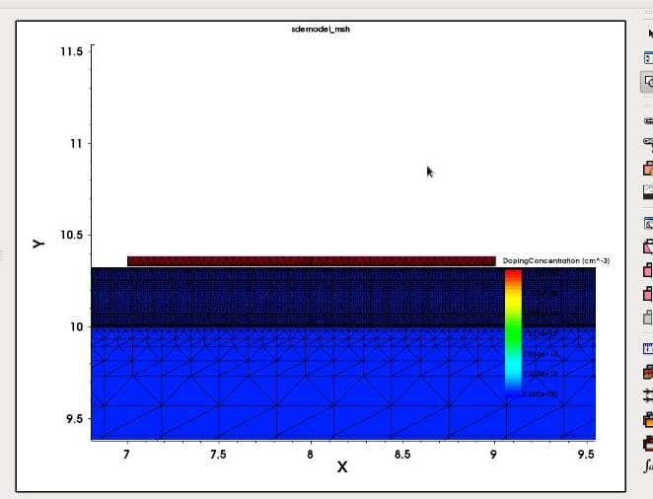

**STAGE 3:**

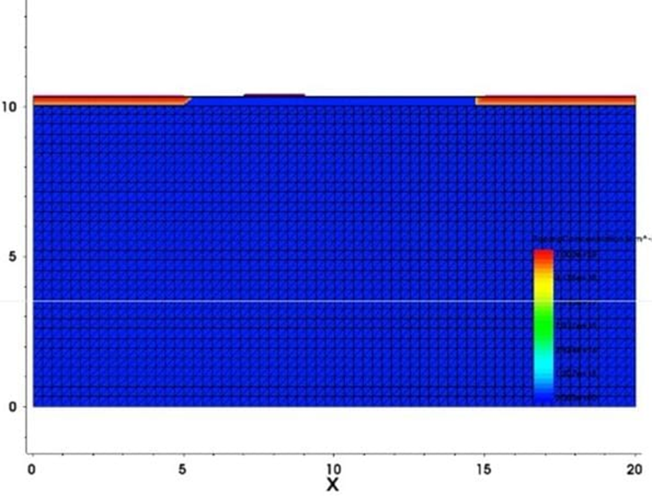

**GRAPHS:**

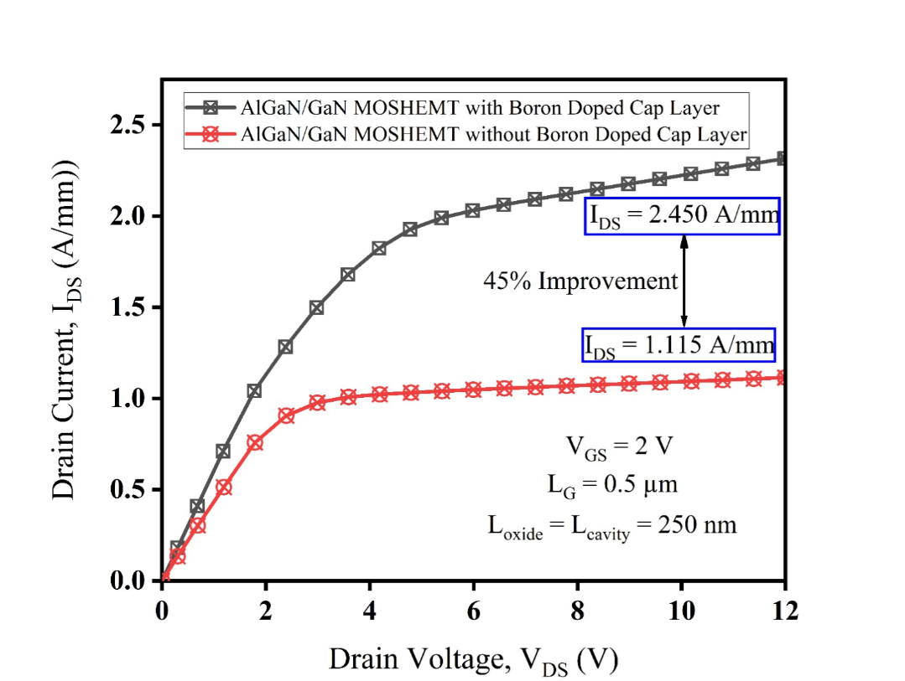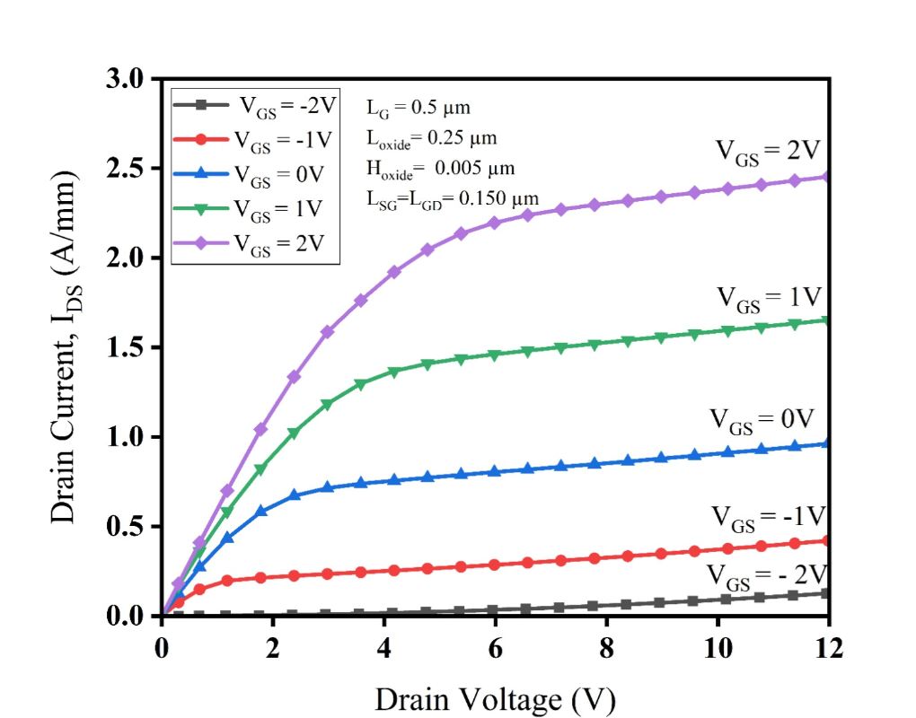

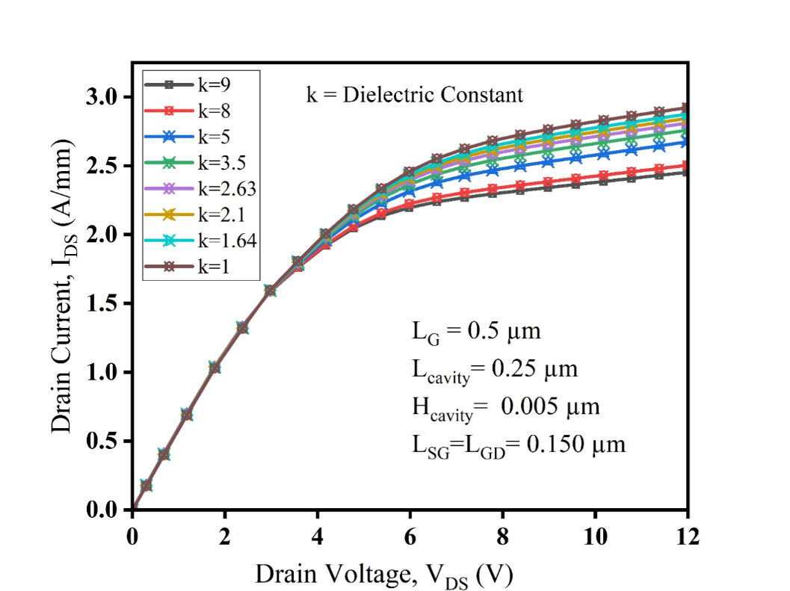 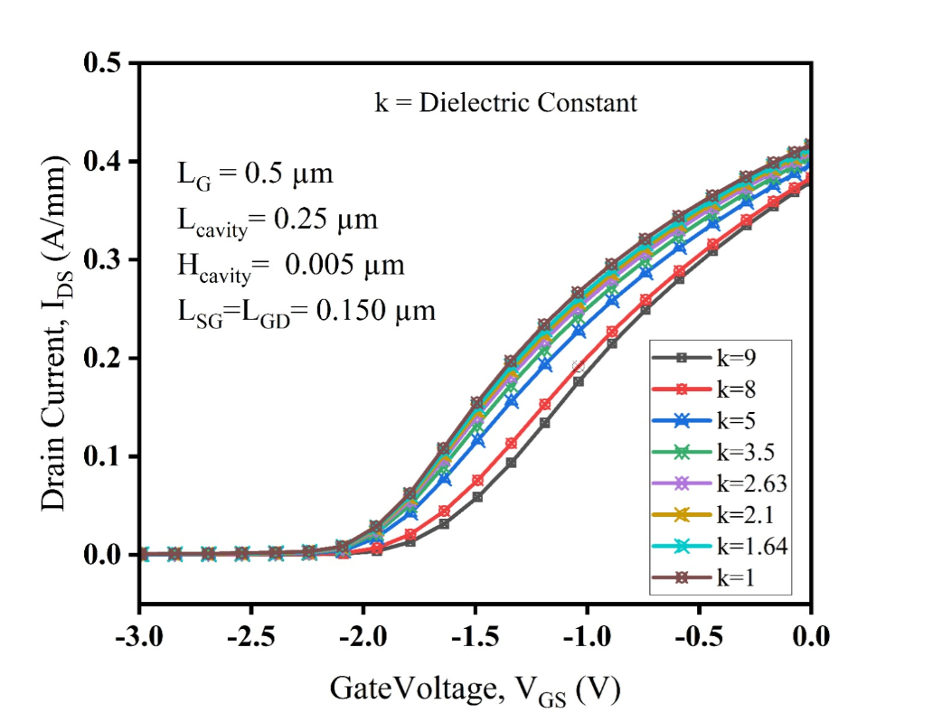

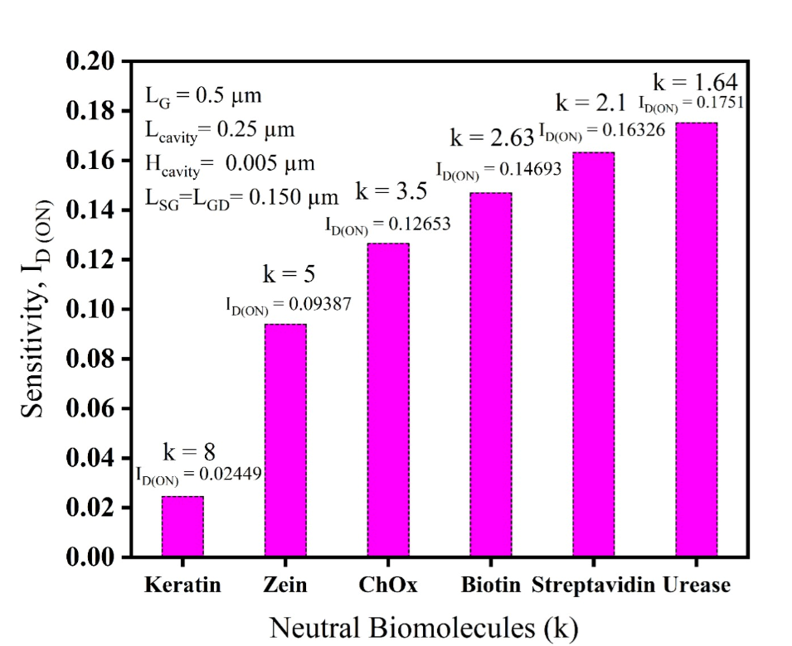

**6.1 outcomes:**

## The simulations of the dielectric-modulated, double AlGaN barrier MOSHEMT demonstrated a significant improvement in sensitivity and selectivity for biomolecule detection. The device was able to detect small changes in biomolecule concentrations, which is critical for accurate biosensing applications.

## The refined design showed optimized electrical characteristics, including a stable drain current and a clear shift in threshold voltage in response to variations in dielectric properties. This indicates a strong correlation between dielectric modulation and the device’s sensing capabilities.

## The results also highlighted the potential of the MOSHEMT design for integration into portable and wearable biosensing devices due to its compact structure and high performance under simulated conditions.

### **6.2 Interpretation of results:**

* **Sensitivity and Selectivity Enhancement:**  
  The observed changes in threshold voltage and drain current validate the effectiveness of dielectric modulation in improving the sensor’s ability to detect low concentrations of biomolecules. The double AlGaN barrier structure contributed to better confinement of carriers, enhancing the device's overall sensitivity.
* **Device Stability:**  
  The simulations showed consistent performance across different environmental conditions, such as temperature and biasing variations, indicating that the device would likely maintain stability in real-world applications. This stability is crucial for applications that require reliable long-term monitoring.
* **Potential for Practical Application:**  
  The results suggest that the MOSHEMT could be effectively used in a range of biosensing applications, including medical diagnostics and environmental monitoring, due to its high precision and ability to function in diverse settings.

#### **6.3 Comparison with existing literature or technologies:**

Compared to traditional biosensors, the dielectric-modulated MOSHEMT shows a marked improvement in sensitivity, achieving a more significant threshold voltage shift with smaller concentrations of biomolecules. This aligns with recent studies that emphasize the role of dielectric modulation in enhancing sensor performance.

In contrast to other AlGaN/GaN-based biosensors, the double-barrier structure in this project provided better electron confinement, which is shown to improve response times and reduce signal noise, as reported in some literature. This suggests that the proposed design offers competitive advantages in terms of speed and accuracy.

While many existing technologies rely heavily on complex fabrication processes, the simulation results of this MOSHEMT indicate a simpler yet effective design, potentially reducing production costs. This aligns with literature advocating for more scalable biosensing solutions but exceeds expectations in terms of ease of fabrication and device miniaturization

# **Chapter 7: Conclusion**

The project successfully designed and simulated a dielectric-modulated, double AlGaN barrier MOSHEMT for enhanced biomolecule detection, demonstrating significant improvements in sensitivity, selectivity, and stability. Through TCAD simulations, the device was shown to detect small changes in biomolecule concentrations with a clear shift in threshold voltage and stable drain current responses. These results validate the effectiveness of using dielectric modulation and a double-barrier structure to enhance the performance of MOSHEMTs in biosensing applications.

The device’s compact design and its ability to maintain consistent performance across varying conditions suggest that it is well-suited for integration into portable and wearable diagnostic tools. This opens opportunities for practical applications in medical diagnostics, environmental monitoring, and other fields that require precise, real-time biomolecule detection.

While the simulation results are promising, the project also highlighted the importance of further experimental validation to ensure that the theoretical performance can be replicated in real-world conditions. Addressing challenges such as fabrication processes and scaling the device for mass production will be crucial for transitioning the design from simulation to practical use.

In conclusion, the dielectric-modulated MOSHEMT developed in this project represents a significant advancement in the field of biosensors, offering a potential solution to the limitations of current technologies. With its high sensitivity, simplified fabrication, and suitability for miniaturization, the device could contribute to the next generation of biosensing technologies, enabling more accessible and accurate diagnostic tools for a wide range of applications.

# **Chapter 8 : Future Work:**

# The promising results of this project lay the groundwork for several avenues of future research and development. To further enhance the potential of the dielectric-modulated, double AlGaN barrier MOSHEMT, the following aspects can be explored:

**8.1 Experimental Validation**

* **Physical Prototyping:**  
  Fabricate the MOSHEMT device based on the optimized simulation parameters to validate the theoretical results through practical testing.
* **Real-World Testing:**  
  Conduct tests under real-world conditions, including varying temperature, humidity, and environmental contaminants, to ensure that the device maintains high sensitivity and selectivity outside of a controlled lab environment.
* **Comparison with Existing Devices:**  
  Benchmark the performance of the fabricated MOSHEMT against existing biosensing technologies to identify areas of improvement and confirm its advantages in practical applications.

**8.2 Optimization of Device Structure**

* **MaterialExploration:**  
  Investigate alternative materials or modifications to the dielectric layer to further enhance electron mobility, sensitivity, and overall device performance.
* **DesignRefinements:**  
  Explore variations in the thickness of the AlGaN and GaN layers or adjustments to the dielectric modulation technique to achieve even better control over threshold voltage shifts and response times.

**8.3 Scalability and Fabrication Techniques**

* **Process Optimization:**  
  Develop and refine fabrication techniques that are scalable for mass production, focusing on maintaining the performance metrics achieved in simulations.
* **Cost Reduction Strategies:**  
  Evaluate methods to reduce the cost of materials and production without compromising the device’s sensitivity or selectivity, making the MOSHEMT more accessible for widespread use.

**8.4 Integration into Portable and Wearable Devices**

* **Miniaturization:**  
  Focus on further miniaturizing the MOSHEMT for easy integration into wearable and portable diagnostic devices, enabling real-time health monitoring and point-of-care diagnostics.
* **Wireless Communication:**  
  Develop wireless communication capabilities for the sensor to allow seamless integration with mobile devices, facilitating data collection and remote monitoring.

**8.5 Broadening Applications**

* **Multifunctional Sensing:**  
  Explore the potential of the MOSHEMT to detect a wider range of biomolecules and chemicals, expanding its applications beyond medical diagnostics to fields such as environmental monitoring, food safety, and industrial process control.
* **Biosensor Networks:**  
  Investigate the use of MOSHEMTs in sensor networks for continuous, large-scale monitoring in environments like hospitals, water treatment facilities, and industrial plants.

**8.6 Long-Term Reliability Studies**

* **Durability Testing:**  
  Conduct long-term reliability tests to assess the stability of the device’s performance over extended periods, ensuring that the MOSHEMT can provide consistent readings in practical applications.
* **Hysteresis and Drift Analysis:**  
  Study hysteresis and drift in the sensor’s response over time to identify any potential challenges that might affect accuracy during long-term use, and develop strategies to mitigate these issues.

#### 

# 

# **References :**

* **Analytical Modeling and Simulation of AlGaN/GaN MOS-HEMT for High Sensitivity pH Sensor.** IEEE Sensors Journal, June 15, 2021.

This paper discusses the simulation of AlGaN/GaN MOS-HEMT structures, focusing on high sensitivity for pH detection and validation against experimental data.

* **Linear and Circular AlGaN/AlN/GaN MOS-HEMT-Based pH Sensor on Si Substrate: A Comparative Analysis.** Published August 18, 2022.

This study compares different designs of AlGaN/GaN MOS-HEMT sensors, providing insights into the sensitivity and calibration techniques for pH sensing applications.

* **High-Sensitivity pH Sensor Based on Coplanar Gate AlGaN/GaN Metal-Oxide-Semiconductor High Electron Mobility Transistor.** Published February 25, 2021.

The paper explores the fabrication and design of high-sensitivity pH sensors using coplanar gate structures, emphasizing improvements in sensitivity and cost-effectiveness.

* **A Dielectric-Modulated Normally-Off AlGaN/GaN MOSHEMT for Bio-Sensing Application: Analytical Modeling Study and Sensitivity Analysis.** IEEE Transactions, Published September 17, 2019.

This study details the fabrication and modeling of a dielectric-modulated AlGaN/GaN MOSHEMT for biosensing, with a focus on the effects of dielectric modulation on sensitivity.

* **Fabrication and Charge Deduction Based Sensitivity Analysis of GaN MOS-HEMT Device for Glucose, MIG, C-erbB-2, KIM-1, and PSA Detection.** IEEE Transactions, 2019.

This research covers the sensitivity analysis of a GaN MOS-HEMT device for various biomarker detections, exploring charge deduction models and the practical challenges of real-time validation.